DEPARTMENT OF COMPUTER SCIENCE AND ENGINEERING
CSA05-DATABASE MANAGEMENT SYSTEMS
DDL Commands – CREATE, ALTER, DROP
EXPERIMENT – 1
CREATE TABLE STUDENT:
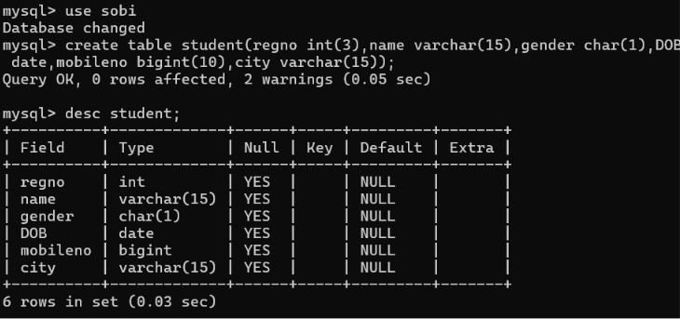

CREATE TABLE FACULTY:

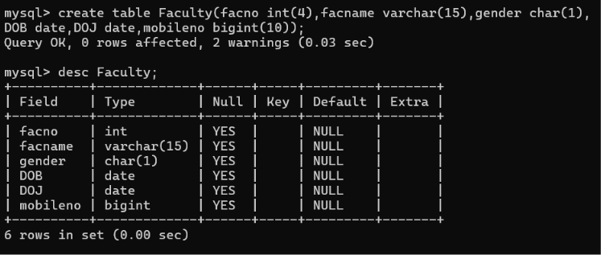
CREATE TABLE DEPARTMENT:
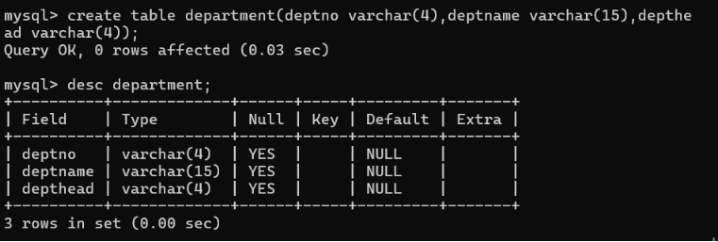
CREATE TABLE COURSE:
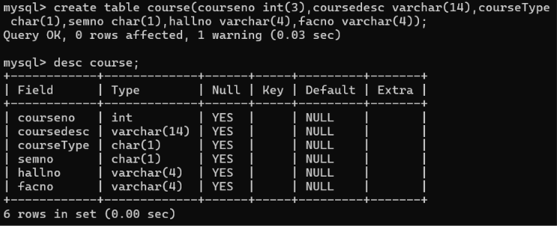
MODIFY THE TABLE FACULTY:
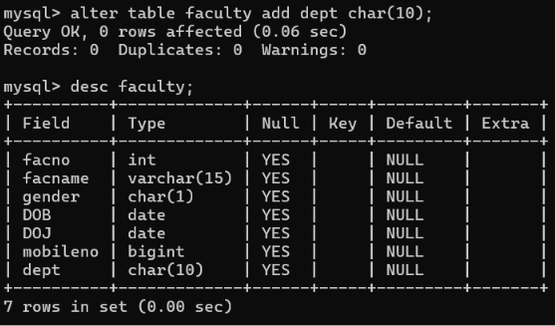

DDL Commands with Constraints – PRIMARY, FOREIGN KEY, UNIQUE, CHECK
EXPERIMENT – 2
